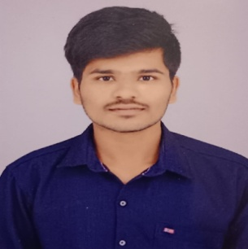
NAME: KISHORE R
MOBILE: 9597096024
E-mail: kk4070080@gmail.com
GitHub: https://github.com/kishore-gitty
Linkedin: https://www.linkedin.com/in/kishore123work
__________________________________________________________________________________________________
CAREER OBJECTIVE
A motivated and detail-oriented Physics graduate with strong analytical and problem-solving skills. Committed to continuous learning and contributing effectively in a dynamic, growth-focused organization.
EDUCATIONAL QUALIFICATION
Qualification | Name of the institution | Board/university | Year of passing | Percentage
B.Sc – Physics | Dr.N.G.P Arts And Science College | Bharathiar  University | 2026 | 77%  (upto 4th sem)
HSC | Govt Hr Sec School | State Board | 2023 | 78.5%
SSLC | Tirupur Public Matriculation School | State Board | 2021 | Nill

TECHNICAL SKILLS:
- PYTHON(basics)
- MS WORD(basics)
- programming in C(basics)
- HTML,CSS (basics)
CERTIFICATIONS:
- NPTEL Certification – Programming, Data Structures, and Algorithms using Python Issued by: NPTEL (Online Course)
- Data Analytics Workshop – Completed a 12-day training organized by Department of Computer Science and Engineering.
Duration: 30 December 2024 – 10 January 2025
- Physics in Action – Participated in Physics In-house Project Exhibition organized by Department of Physics, Dr. NGP Arts and Science College. Date: 14 August 2024
MY PROTFOLIO:
- Link = https://kishore-gitty.github.io/my_protfolio_kishgitty_v1/

INTERNSHIP:
- KPR Institute of Engineering and Technology, CoimbatoreUnder the guidance of Dr. S. Mohanraj, CFRD Project: Synthesis of Copper Halide Perovskite
Duration:15days
LANGUAGE KNOWN:
- Tamil
- English
ACHIEVEMENT:
- Oral Presentation – ICMFM-2025
Delivered a presentation on “Synthesis of Copper Halide Perovskite” at Sri Sairam Engineering College, based on my internship project under CFRD, KPRIET. Awarded Certificate of Appreciation. Held on 11.09.2025 & 12.09.2025

DECRALATION :
I hereby declare that the above information furnished by me is true to the best of my knowledge and belief

